**Setting Up Application Environment**

**Create Sendgrid Account**

|  |  |
| --- | --- |
| Team ID | PNT2022TMID34000 |
| Project Name | Customer Care Registry |

# **Step 1:**Open Sendgrid account and Create API

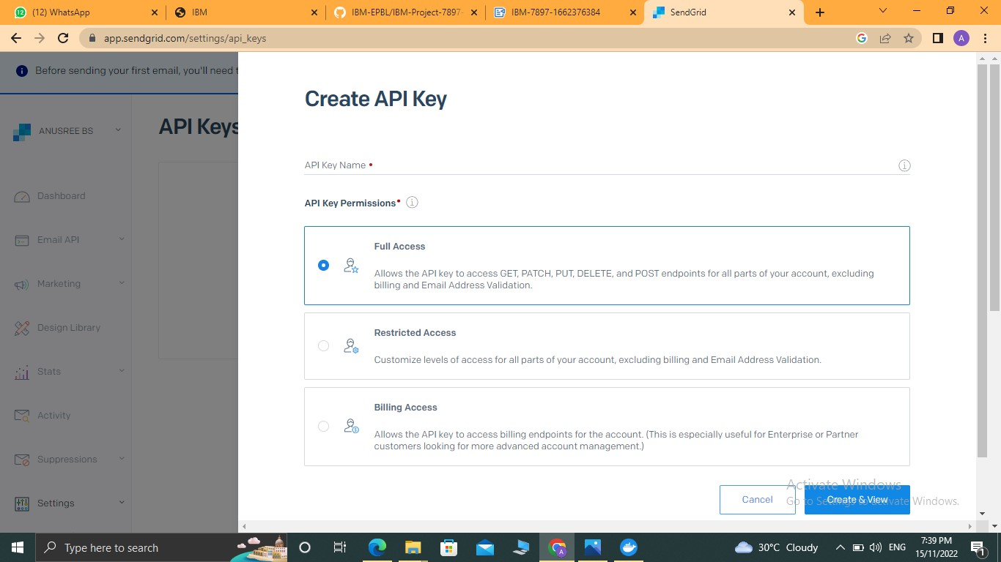

# **Step 2**: Set Environmental Variable using "API KEY" and pip install sendgrid in cmd

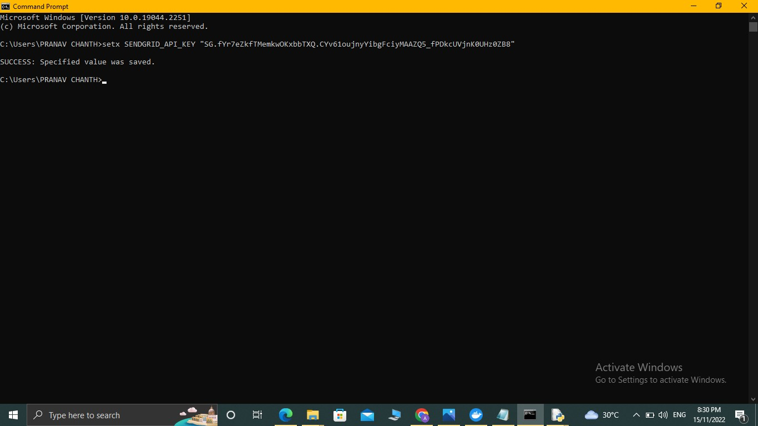

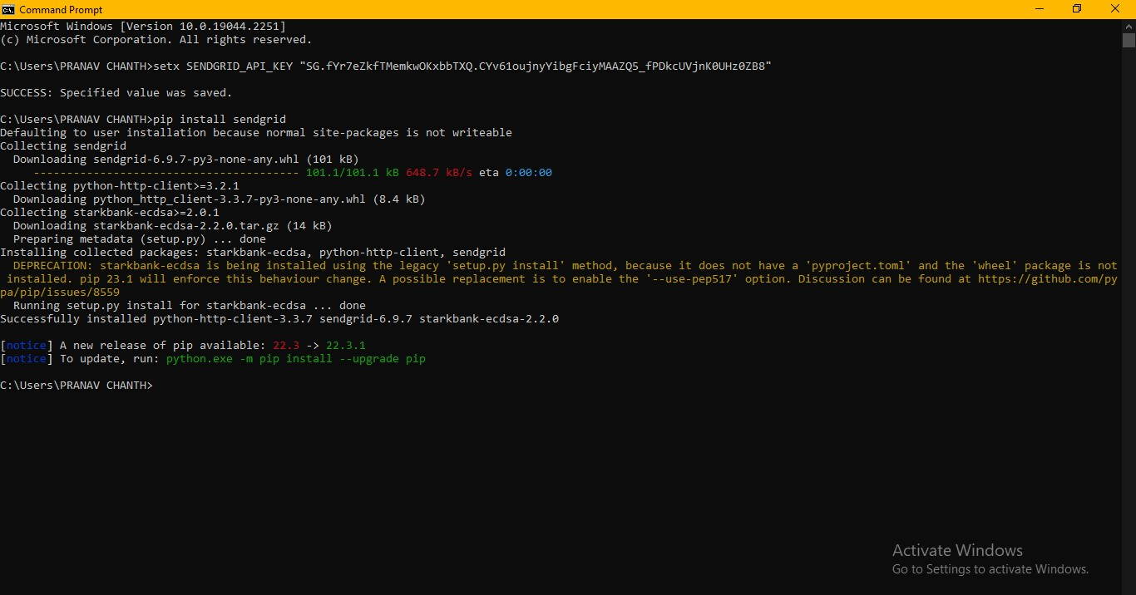

# **Step 3:** Integrate Sendgrid using Python code and Test with mail ids and run in cmd

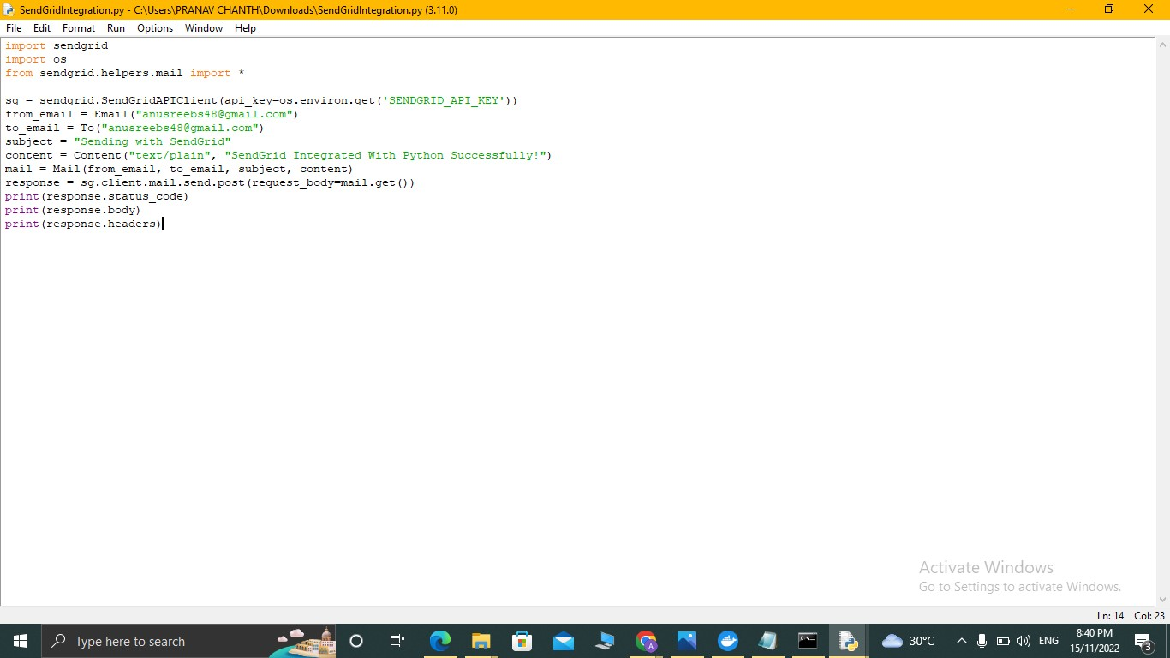

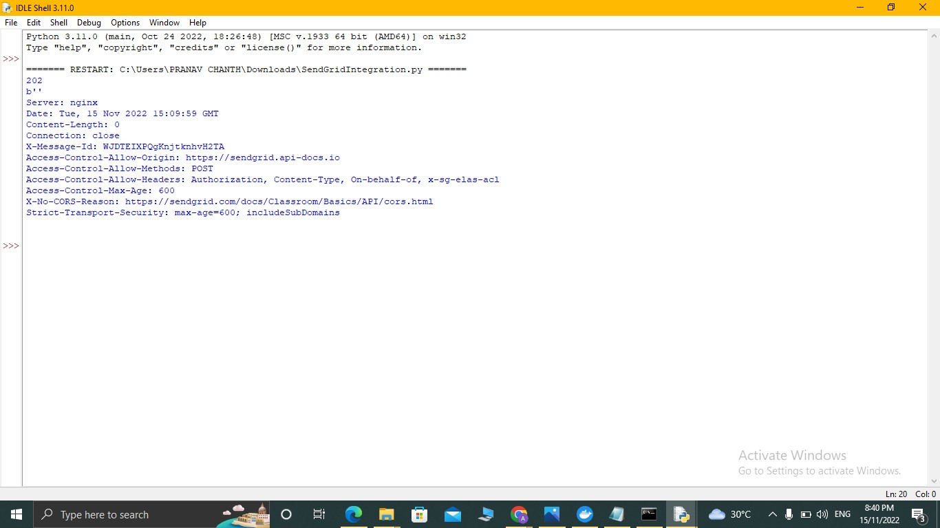

**Output:**

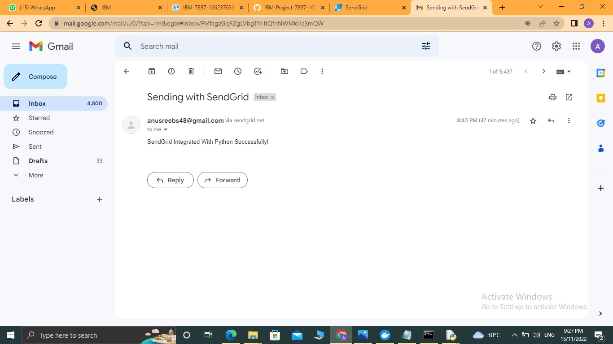

# Sendgrid email API integrated with python Successfully